**Example Usage Instructions**

1. **Dataset Construction**

We slice continuous lunar seismic recordings into fixed-length segments (in this study, we use a window length of 100 seconds and a step size of 50 seconds), and save all the resulting segments into an HDF5-format dataset. The file **dataset_test.hdf5** is a directly runnable example dataset provided with this work. Its time range is March 1 - 7, 1973 (7 days).

Each dataset contains multiple Groups (data segments), with each group representing a specific time window. Groups are named using the following format:

*{Unix Timestamp (UTC)}-{Station}-{Component}*

Inside each group:

The seismic waveform data is stored in a dataset named *data*.

Additional data types (e.g., amplitude spectra) can be added as needed, such as a spectrum dataset.

To store metadata, we include a *label* dataset representing the start time of the segment (in Unix timestamp format). More metadata fields can be added as required.

Example Dataset Structure:

dataset_test.hdf5

├── 1015027200.0-12-MH1

│ ├── data → float32[1, L] # Seismic waveform

│ ├── label → float64 # Start time (UTC)

│ └── spectrum → float32[...] # (Optional) others

├── 1015027300.0-12-MH1

│ ├── ...

1. **Model Parameter Configuration**

‘**deepcluster_example.py**’ is the main script implementing the DeepCluster framework. The `**models**`, `**unil**`, and `**clustering**` modules define the CNN backbone, training utilities, and clustering logic essential for unsupervised learning with DeepCluster.

Before running it, you need to configure the following key parameters:

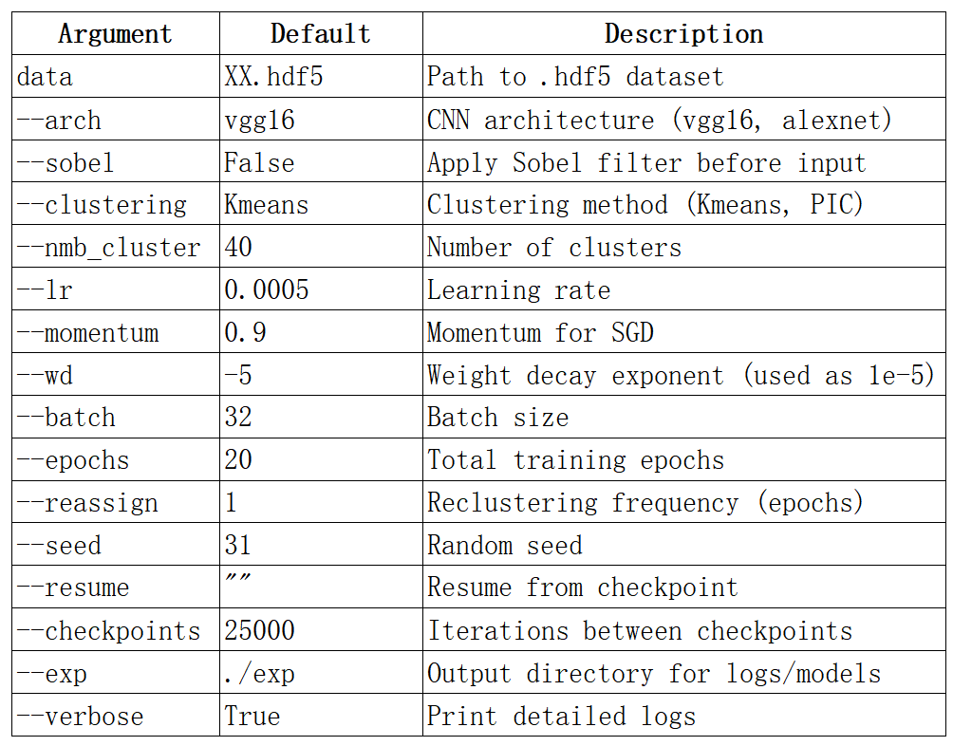

Data Preprocessing:

Each input sample:

Reshaped to (1, *640*)

The specific length needs to be adjusted according to the selected data length

and be consistent with the model.

Normalized using z-score (zero mean, unit variance)

1. **Run DeepCluster**

Example Command:

python deepcluster_example.py dataset_test.hdf5 \

--arch vgg16 \

--clustering Kmeans \

--nmb_cluster 40 \

--batch 32 \

--epochs 20 \

--lr 0.0005 \

--exp ./exp/ \

--verbose